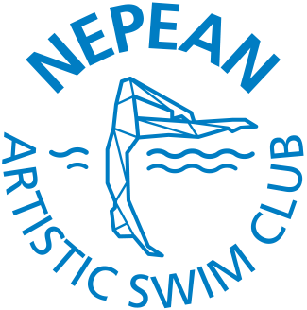

Nepean Artistic Swim Club (NASC)
Annual General Meeting Minutes
Sunday, November 5, 2022, 9:00-10:00 am
Water Safety Room, Nepean Sportsplex

The meeting was called to Order at 9:04 a.m.
The meeting rules were read as follows:
  - Attendees are to sign attendance sheet, list attached in annex A
  - Members have 1 vote per competitive swimmer
  - Ordinary Resolutions require a 50%+1 vote to pass
  - Special Resolutions require ⅔ majority vote to pass
  - Extraordinary Resolutions require 80% majority vote to pass
  - Nepean Synchro is not for profit corporation
  - AGM notice was e-mailed to members on Monday, October 9th
  - It must be held within 6 months after the end of the fiscal year, which is June 30th for our club
  - The main purpose is to approve the financial statements for the past fiscal year & the previous AGM minutes, & to appoint new directors if necessary

- Introduction of current Board of Directors
  - Vice-President, Megan Rakoczy was voted in last year for a two year term
  - Nominations called for the President position, Laura Neal was confirmed by the Board in March 2023. Requested any other interested parties nominations, none were volunteered. Motion for Laura Neal to serve as president for a two year term was motioned by Andrew Bird and seconded by Ryan Doraty. Motion carried unanimously.
- Approval of the 2022 Annual General Meeting minutes were read, motion to accept the 2022 AGM meeting minutes by Lindsay Kemp and seconded by Stephanie Willie. Motion carried unanimously.
- Election to Board of Directors
  - Treasurer: Seeking nominations, no nominations received at this time.
  - Director of Rec/Novice: Genna McBain, 1-year extension, motioned by Laura Neal, seconded by Andrew Bird, motion carried unanimously.
  - Secretary: Christine Saveland. Nominated by Laura Neal and seconded by Marina Petrovic; motion was carried unanimously.
  - Director of Operations: Robyn Whittaker nominated by Laura Neal, seconded by Ryan Doraty, motion carried unanimously.
- Approval of the 2022-2023 Financial statements. Mike Blanchard, outgoing treasurer presented the financial statement and the draft copy from the accountants Kelly Huibers McNeely. Motion to approve the fiscal year 2022-23 financial statement by Elyn Humphreys, seconded by Andrew Bird, motion carried unanimously.
- Approval of Kelly Huibers McNeely to remain as accountants/auditors to the Club for the 2023/24 fiscal year motioned by Laura Neal, seconded by Ryan Doraty, motion carried unanimously.
- Adjournment of Annual General Meeting at 9:38 a.m.

Laura Neal 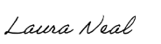 6 Nov 2023
President Signature Date

Megan Rakoczy 6 Nov 2023
Vice President Signature Date

Addendum:
ON 8 Nov 2023, Yanwu Wang indicated her interest in the Treasurer position and was confirmed by a unanimous board vote.

